In considering the influence school type may have on default rates, it was essential to identify the various levels that comprised the variable. The PEPS300 data frame obtained from the Department of Education coded the “School Type” variable with 6 levels: 1 (Public Institutions), 2 (Private-Non-Profit Institutions), 3 (Proprietary Institutions), 5 (Foreign, Public Institutions), 6 (Foreign, Private-Non-Profit Institutions), 7 (Foreign, Proprietary Institutions).

The PEPS300 data frame, from which we obtained the “School Type” variable was read in with school type showing as a numeric variable with levels 1, 2, 3, 5, 6, 7. After the data was merged using matching UNIT_ID and OPEID numbers and after omitting incomplete cases, three levels for school type were omitted entirely—5 (Foreign, Public Institutions), 6 (Foreign, Private-Non-Profit Institutions), 7 (Foreign, Proprietary Institutions). It left 1339 observations of 1 (Public Institutions), 1175 observations of 2 (Private Institutions) and 304 observations of 3 (Proprietary Institutions). Unfortunately, the data merge (and subsequent purge of incomplete cases) trimmed our data to less than a third of the institutions that were initially included in the PEPS300 data.

Before analyzing the data for distributions, trends, and correlations, the class of the school type variable was changed to “factor” and the levels were renamed from numerical values to their corresponding categorical variable names (Public, Private, and Proprietary). This was especially useful in visualizing and analyzing the data in various summary tables and plots (Appendix 4 – 8). .

In considering a simple snapshot of default rates among the three remaining school types, a summary table was created to capture the mean default rate based on school type. The combined, unflattened data frame was grouped by variables school type and year and the value.var was set as the mean of the default rate column. In observing these rates (Appendix 4), it is clear that on average, private institutions had the lowest percentage of students in default. In 2012, the average default rate a private institutions was just 6.8 percent, compared to 14.08 percent at public institutions and 12.79 percent at proprietary institutions. In 2013, a similar percentages were observed, with private institutions leading the way. That year, on average 6.73 percent of private school students were in default compared to 13.75 percent of students at public institutions and 12.01 percent at proprietary institutions.

After considering average default rate, a deeper analysis was conducted to assess how these institutions were performing as it relates to Department of Education performance standards. According to the Department of Education’s “Instructions for using the School Cohort Default Rate Reports,” we learn that institutions maintaining cohort default rate of 15% or below for three consecutive years have greater autonomy with when and how they disburse financial aid awards. When institutions are meeting the DOE benchmark, they can disperse funds at any point over the course of the academic year and as many (or as few) times as they would like throughout the year.

To identify which school types were most likely to meet this DOE benchmark, a summary table (Appendix 5) was developed from the unflattened data frame, grouping together two variables—school type and year with the value.var set as the percentage of each school type with default rates 15 percent or below. Private institutions led the way in percentage of schools meeting the sub-15 percent metric. In 2012, 91.5 percent of private schools had default rates at or below 15 percent. That number increased to 92 percent in 2013. Proprietary institutions turned in the second strongest results with this benchmark. In years 2012 and 2013, with 64.7 and 67.7 percent of proprietary schools met the DOE standard. Public institutions performed worst in this area with 56.6 percent and 55.9 percent of institutions posting sub-15 percent default rates in 2012 and 2013, respectively.

On the other end of the spectrum, the Department of Education also monitors institutions with default rates at or above 30 percent. These institutions could be subject to the loss of eligibility to participate in federal financial aid programs such as Federal Family Education Loan, Direct Loan and/or Pell Grant. The loss of eligibility can be detrimental to an institution’s financial ability to operate.

A summary table (Appendix 6) was generated to identify which school types could be considered ‘most at risk’ by not meeting DOE standards. The unflattened data frame was again, grouped by school type and year, but this time with the value.var set as the percentage of each school type with default rates at 30 percent or higher. While all school types boast relatively low percentages in this area, proprietary institutions observed in this data set performed best. Of the 304 institutions observed, there weren’t any that had a default rate of 30 percent or greater in either 2012 or 2013. Private institutions also performed well, with .5 percent of schools posting rates of 30 percent or greater in 2012 and just .1 percent of schools the following year. Public institutions lagged behind their counterparts as approximately 1.5 percent of schools had default rates of at least 30 percent in 2012. Public schools, however, improved in that metric, with just .8 percent turning in default rates of 30% or more in 2013.

In addition to summarizing data from the School Type variable, plots were also generated to visualize how variables were correlated with one another. A scatter plot (Appendix 7) was generated to measure the default rate over cost of tuition for years 2012 and 2013. Within the scatter plot, school type is identified by color. The plot shows clear separation between the three school types, with Public Institutions boasting lower cost of tuition, but higher default rates, private institutions showing higher cost of tuition, but lower default rates and proprietary institutions occupying the space in between for both variables.

A boxplot, with jitter (Appendix 8), was also generated to compare default rate against school type. This plot is especially useful in identifying how the observations were distributed among the three school types. It shows that the default rates of public institutions are evenly distributed between all default rates 0 – 30 percent. Public institutions also had the highest median default rate. Private institutions had, by far, the lowest median default rate, with a majority institutions observing default rates at or below 5 percent. This plot also shows population density of each school type and provides insight into how well each school type is represented in the data set. The plot shows that public institutions were the most represented school type while proprietary institutions were the least represented.

Through this analysis, it appears that school type and default rate may be correlated. By observing the tables and plots generated in Appendices 4 – 8, it is clear that Private Institutions outperform both Public Institutions and Proprietary Institutions when considering some of the most important metrics the Department of Education assesses when regulating student loan practices and policies. In addition, public institutions are *least* likely to meet the same, Department of Education benchmark metrics. Unfortunately, the analysis doesn’t capture a complete picture of the influence of school type may have on default rates. The levels that are observed in the school type variable are fairly broad. For instance, included in the Public Institution level are both community colleges and four-year colleges and universities. Though considered the same level by the DOE definitions, these institutions have very different programs and structures, while serving different student demographics. Likewise, short-term, vocational/technical schools and universities offering bachelor and graduate degrees are both included in the proprietary school level—two entirely different target student populations. With such a wide range of institutions comprising each level of the school type variable, it is difficult to draw a clear-cut conclusion from the insight we are gleaning from our data. Through exploratory analysis, the data offers an interesting perspective on a possible correlation between school type and default rate. Ultimately, however, added levels to the Department of Education school type definitions would provide the most valuable insight on how the two variables are related.

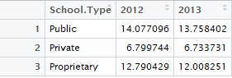Summary Table: Average Cohort Default Rate for School Type by Year

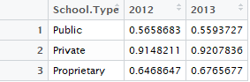Summary Table: Percentage of Institutions with Default Rates ≤ 15%

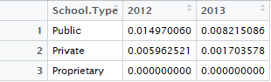Summary Table: Percentage of Institutions with Default Rates ≥ 30%

Scatter Plot: Default Rate vs. Tuition with School Type

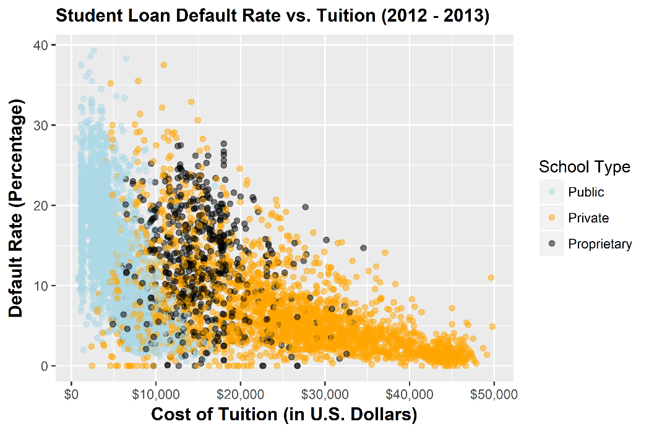

Boxplot w/Jitter: Default Rate vs. School Type

